Iona Medical Centre
Privacy Policy
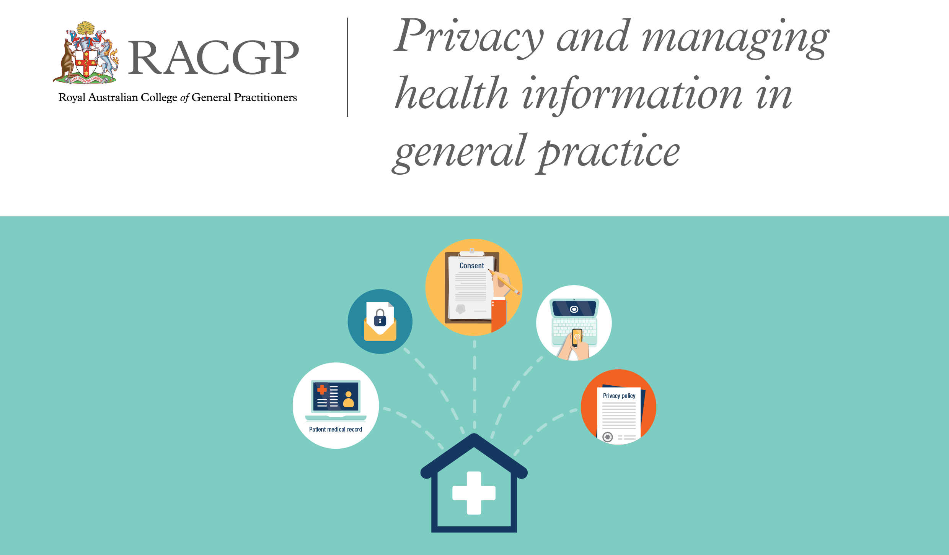
Version: | Reviewed by: | Date:
I | Melanie Mulhare | 15/12/15
2 | Julie Naumann | 2/12/16
3 | Julie Naumann | 12/12/17
4 | Melanie Wooldridge | 17/6/18
5 | Melanie Wooldridge | 06/08/2019

Iona Medical Centre - Privacy Policy
Current as of: 06/08/2019
Introduction
This privacy policy is to provide information to you, our patient, on how your personal information (which includes your health information) is collected and used within our practice, and the circumstances in which we may share it with third parties.
Why and when your consent is necessary
When you register as a patient of our practice, you provide consent for our GPs and practice staff to access and use your personal information so they can provide you with the best possible healthcare. Only staff who need to see your personal information will have access to it. If we need to use your information for anything else, we will seek additional consent from you to do this.
Why do we collect, use, hold and share your personal information?
Our practice will need to collect your personal information to provide healthcare services to you. Our main purpose for collecting, using, holding and sharing your personal information is to manage your health. We also use it for directly related business activities, such as financial claims and payments, practice audits and accreditation, and business processes (eg staff training).
What personal information do we collect?
The information we will collect about you includes your:
- names, date of birth, addresses, contact details
- medical information including medical history, medications, allergies, adverse events, immunisations, social history, family history and risk factors
- Medicare number (where available) for identification and claiming purposes
- healthcare identifiers
- health fund details.
Dealing with us anonymously
You have the right to deal with us anonymously or under a pseudonym unless it is impracticable for us to do so or unless we are required or authorised by law to only deal with identified individuals. However, it is important for you to understand that if this is the case, we cannot claim your benefits from Medicare, even if you hold a health care card or pension card. If this applies to you, please speak directly to your doctor during your consultation.
How do we collect your personal information?
Our practice may collect your personal information in several different ways.
- When you make your first appointment our practice staff will collect your personal and demographic information via your registration. The registration form you are given on arrival will cover why we collect this information. You are welcome to speak with our practice staff if you have any questions regarding this form.
- During the course of providing medical services, we may collect further personal information. This personal information is likely to come from third parties such as your previous practitioner, other allied health professionals or a hospital that you have previously attended. Please note that we may collect this information through electronic transfer ( i.e. Shared Health Summary via My Health Record). Please speak directly to your doctor during your consultation if you have any concerns surrounding this.
- We may also collect your personal information when you visit our website, telephone us, make an online appointment or communicate with us using social media.
- In some circumstances personal information may also be collected from other sources. Often this is because it is not practical or reasonable to collect it from you directly. This may include information from:
- your guardian or responsible person
- other involved healthcare providers, such as specialists, allied health professionals, hospitals, community health services and pathology and diagnostic imaging services
- your health fund, Medicare, or the Department of Veterans’ Affairs (as necessary).
When, why and with whom do we share your personal information?
We sometimes share your personal information:
- with third parties who work with our practice for business purposes, such as accreditation agencies or information technology providers – these third parties are required to comply with APPs and this policy
- with other healthcare providers
- when it is required or authorised by law (eg court subpoenas)
- when it is necessary to lessen or prevent a serious threat to a patient’s life, health or safety or public health or safety, or it is impractical to obtain the patient’s consent
- to assist in locating a missing person
- to establish, exercise or defend an equitable claim
- for the purpose of confidential dispute resolution process
- when there is a statutory requirement to share certain personal information (eg some diseases require mandatory notification)
- during the course of providing medical services, through eTP, My Health Record (eg via Shared Health Summary)
Only people who need to access your information will be able to do so. Other than in the course of providing medical services or as otherwise described in this policy, our practice will not share personal information with any third party without your consent.
We will not share your personal information with anyone outside Australia (unless under exceptional circumstances that are permitted by law) without your consent.
Our practice will not use your personal information for marketing any of our goods or services directly to you without your express consent. If you do consent, you may opt out of direct marketing at any time by notifying our practice in writing.
How do we store and protect your personal information?
Our practice stores all personal information securely.
Your personal information is stored at our practice in electronic form.
Our practice is considered paperless and has systems in place to protect the privacy, security, quality and integrity of the personal health information held electronically. Appropriate staff members are trained in computer security policies and procedures.
Our practice ensures that our practice computers and servers comply with the RACGP computer security checklist and that:
- computers are only accessible via individual password to those in the practice team who have appropriate levels of authorisation.
- computers have screensavers or other automated privacy protection devices are enabled to prevent unauthorised access to computers.
- servers are backed up and checked at frequent intervals, consistent with a documented business continuity plan.
- back up information is stored in a secure off site environment.
- computers are protected by antivirus software that is installed and updated regularly
- computers connected to the internet are protected by appropriate hardware/software firewalls.
- we have a business continuity plan that has been developed, tested and documented.

Electronic data transmission of your health information from our practice is in a secure format.
This practice has a sound backup system and a contingency plan to protect your health information in the event of an adverse incident, such as a system crash or power failure. This plan encompasses all critical areas of the practice’s operations such as making appointments, billing patients and collecting patient health information. This plan is tested on a regular basis to ensure backup protocols work properly and that the practice can continue to operate in the event of a computer failure or power outage.
How can you access and correct your personal information at our practice?
You have the right to request access to, and correction of, your personal information.
Our practice acknowledges patients may request access to their medical records. We require you to put this request in writing and sign and date your request. Our practice will respond within a reasonable time. You may mail this request to Iona Medical Centre, 129 Russell Street, Toowoomba, QLD, 4350, or bring it to the practice yourself. Our practice will respond within a reasonable time. Please note that depending on what you request and how much printing is involved, there may be a fee. We will not issue you with an account without first discussing this with you. Please speak to our practice staff if you have any questions regarding this.
Our practice will take reasonable steps to correct your personal information where the information is not accurate or up to date. From time to time, we will ask you to verify that your personal information held by our practice is correct and current. You may also request that we correct or update your information, and you should make such requests in writing. You may mail this request to Iona Medical Centre, 129 Russell Street, Toowoomba, QLD, 4350 or bring it to the practice yourself.
Electronic Communication with the practice (i.e. email).
This practice takes every precaution possible to ensure that patient’s electronic communication with the practice (i.e. email) remains private and confidential. However, it is important for patients to be aware of the risks associated with electronic communication, in that the information could be intercepted or read by someone other than the intended recipient. For this reason, we do not transmit health information by email.
How can you lodge a privacy-related complaint, and how will the complaint be handled at our practice?
We take complaints and concerns regarding privacy seriously. You are welcome to express any privacy concerns you may have in writing or verbally with our practice staff. We will then attempt to resolve it in accordance with our resolution procedure. If you would like more information on this procedure, please speak with our practice staff. You are welcome to complain anonymously if desired. Our contact details are as follows:
Postal address:
129 Russell Street, Toowoomba, QLD, 4350 (you should address this to ‘The Practice Manager’)
Phone number:
(07) 46 322 331 (you should ask to speak with the Practice Manager)
We will typically respond to your complaint within a time frame of 3-5 business days. Please note that complaints which are heavily involved could take longer. If this is the case, we will inform you as soon as possible.
You may also contact the OAIC. Generally the OAIC will require you to give them time to respond, before they will investigate. For further information visit www.oaic.gov.au or call the OAIC on 1300 336 002.
Privacy and our website / Social media
We will not disclose any of your personal or health information on our website or on our Facebook page. However, in some instances, we may ask if we can take your photo to be displayed on our website or our Facebook page. We will not do so without your permission.
Policy review statement
This policy is reviewed on an annual basis to ensure it complies with all state and national privacy policies.

