

IONA MEDICAL CENTRE

NEWSLETTER

June – July 2020

**For medical attention at any time please call 46 322 331. Please note, private fees apply for consultations outside of normal hours.**

**OPENING HOURS**

**MONDAY – FRIDAY**

**8.30am – 5.00pm**

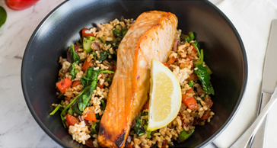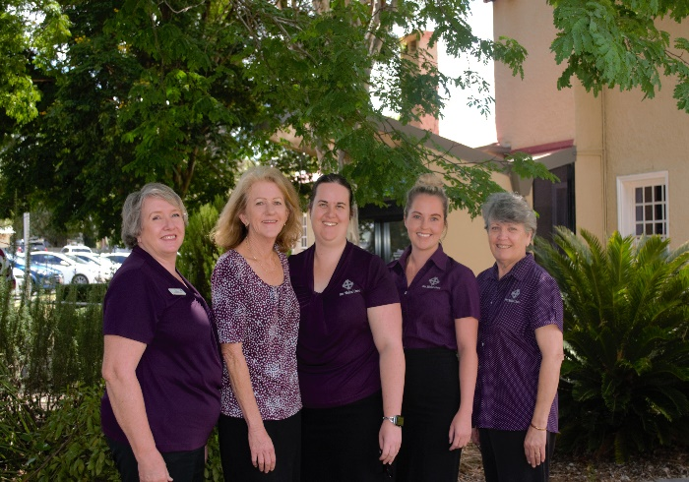

OUR DOCTORS

Dr Clinton Dowling

Dr Daniel Rouhead

Dr James Ingram

Dr Allan Wong

Dr Megan Poppi

Dr Tony Ferris

Dr Valerie Chua

Dr Maria Haase

Dr Ria Pai

**Sticky Baked Salmon with Brown Rice**

**Ingredients**

* 3 Tbsp. salt reduced soy sauce
* 2cm piece of Ginger finely grated
* 2 Garlic Cloves, finely grated
* 2 Tbsp. Honey
* 4 x 100g skinless salmon fillet
* Olive oil spray
* 1 red onion, finely chopped
* 1 red capsicum, thinly sliced lengthways
* 2 bunches of broccolini, cut into quarters
* 4 cups of baby spinach
* 2 cups ’90 second quick’ brown rice

**Method**

1. Combine 2 tablespoons soy sauce, ginger, garlic and honey in a shallow dish. Add the salmon fillets, turn to coat.
2. Preheat oven to 180°C. Line a baking tray with baking paper.
3. Place the marinated salmon onto the baking tray and spoon the leftover marinade onto the salmon fillets. Bake in the oven for 10-15 minutes.
4. Meanwhile heat a large wok over medium heat and lightly spray with olive oil. Stir fry red onion, capsicum and broccolini for 5-6 minutes. Add spinach and stir-fry for 2 minutes, or until vegetables are just tender.
5. Meanwhile, heat microwave brown rice according to packet instructions.
6. Add steamed brown rice and remaining soy sauce; stir fry until heated through. Keep warm.
7. Serve baked salmon on the vegetable brown fried rice



**Latest Flu Vaccine News!**

If you haven’t had your annual flu vaccine, please see reception to book an appointment.

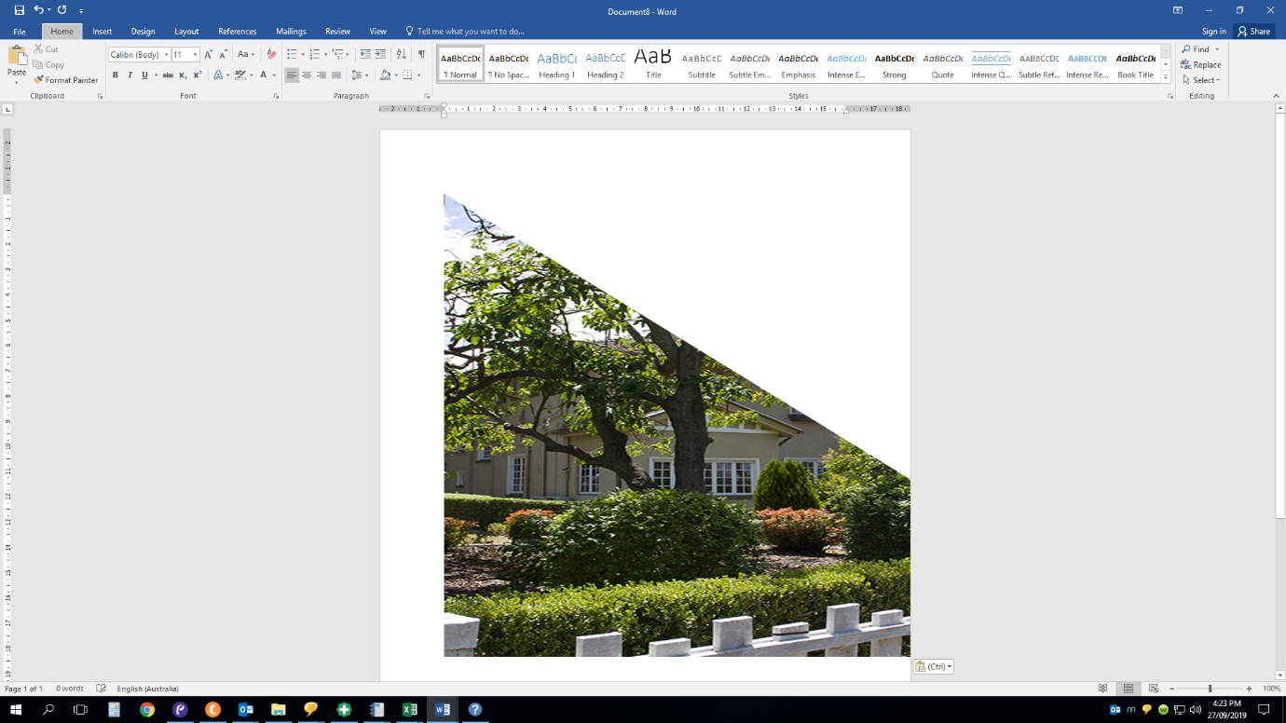

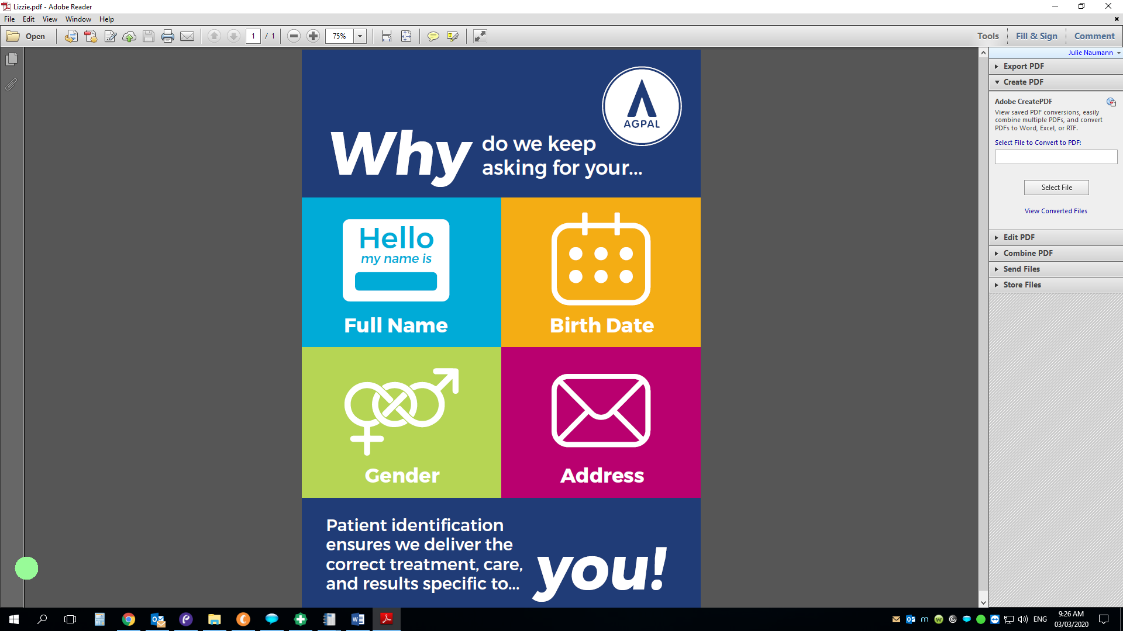

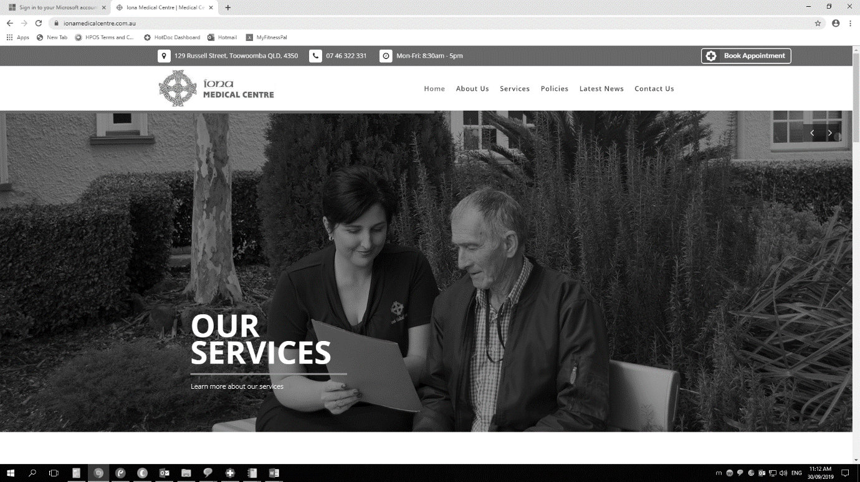

**THANK-YOU FOR YOUR FEEDBACK**

Thank-you to everyone who completed a patient feedback survey during July- August.

From your feedback, it has been identified that you would like to know when your GP will be away from the surgery.

To help you, we now have a regular section in our newsletter, listing doctor’s planned absence.

Please see below for a current list.

**DOCTORS AWAY FROM THE SURGERY**

DR PAI DR ROUHEAD

July 6th – 13th June 19th – 26th

**WORKCOVER CLAIMS**

If you are seeing a doctor regarding a **work related injury,** please be aware that your account is, ***payable in full on the day of your consult***.

If you are provided with a claim number, subsequent visits may be able to be lodged for you.

**DR DOWLING’S JOKE OF THE MONTH**

A joke about steak is a rare medium well done.

**PLEASE UPDATE YOUR DETAILS**

**Without your correct mobile phone number and postal address, we may not be able to contact you to confirm your appointment or to let you know about important health reminders.**

**Check with reception to ensure your mobile number, postal address and Next of Kin and or emergency contact details are up-to-date.**

**PLEASE NOTE: We now require a Next of Kin, as well as an emergency contact for you. If this person is the same for each, that is ok!**





***If you have an appointment at the practice…***

**Please arrive at the time of your appointment. This is to limit the amount of time spent in the waiting room and to limit the number of patients in the waiting room.**

**Thank-you for your cooperation**

**Care Plan Review Appointments & Covid-19**

If you receive an SMS or phone call stating that, you are now due for your next care plan review….

You have the following options:

1. To book your appointment as usual (by phoning or going online) and come to the practice

1. To book your appointment and let us know you would like our nurses to phone you at home for the appointment
2. Postpone your appointment for a later date. Please phone us to discuss this option

